* **useContext()**
  + Cho phép làm việc với context trong functional component
  + Return value React.createContext

VD1: Context bài trước

|  |  |  |
| --- | --- | --- |
| *B1: create context object* | *B2: create provider* | *Component trung gian không cần truyền props gì cả* |

|  |  |  |
| --- | --- | --- |
| *Functional Component* | *Class Component* | *Context Hook* |

*B3: create consumer (using context)*

VD2: multiple context

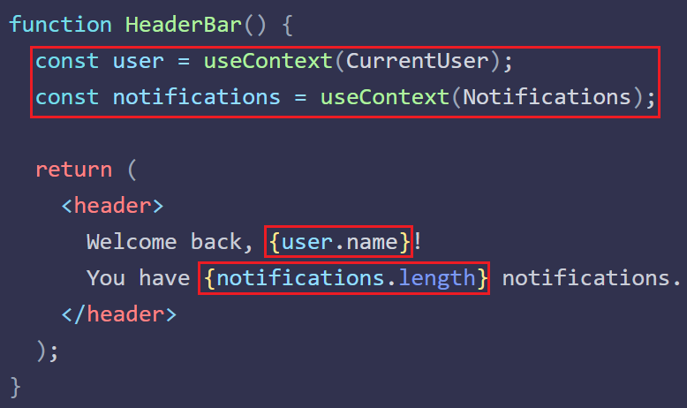

* **Reference**

<https://reactjs.org/docs/context.html>